**UDOO INSTALL TUTORIAL**

**Main page:** <https://www.udoo.org/>

1. Go to <https://www.udoo.org/downloads/> and download the images for Udoo Neo. Its name UDOOBUNTU, then use [Win32 Disk Imager](https://sourceforge.net/projects/win32diskimager/) to create a bootable MicroSD card. I have done this task already so you could check out your-self at this link <https://www.udoo.org/docs-neo/Introduction/Introduction.html>.
2. Because we don’t have Mirco HDMI cable so we use USB Direct Connection:

* Plug in power cable and Micro USB or only Micro USB to connect UDOO NEO with computer (I recommend using USB 3.0 if you don’t have power cable)
* If you’re doing right, Connecting UDOO NEO to your computer will result in:
* UDOO NEO powering on, taking power from its USB Port
* A storage device will be available, containing UDOO NEO'S Kernel and DTB files, together with an offline documentation and quick start guide
* Then you will get the following message:

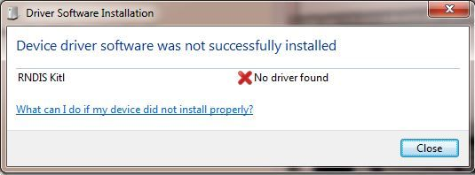

* Right click on Computer and select Manage. From System Tools, select Device Manager. It will show a list of devices currently connected with the development PC. In the list, RNDIS Kitl can be seen with an exclamation mark implying that driver has not been installed.

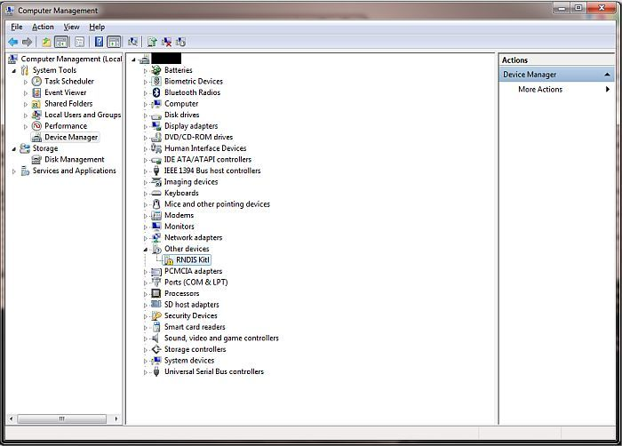

* Right click on it and select Update Driver Software... When prompted to choose how to search for device driver software, choose Browse my computer for driver software.
* Browse for driver software on your computer will come up. Select Let me pick from a list of device drivers on my computer.
* A window will come up asking to select the device type. Select Network adapters, as RNDIS emulates a network connection.

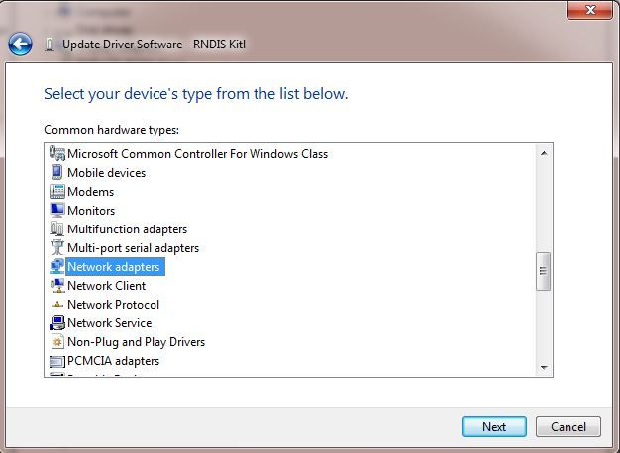

* In the Select Network Adapter window, select Microsoft Corporation from the Manufacturer list (I use Win 10 so I choose Microsoft instead). Under the list of Network Adapter:, select Remote NDIS compatible device.

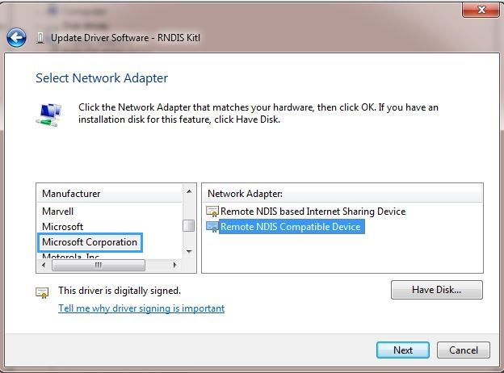

* The RNDIS Kitl device is now installed and ready for use.

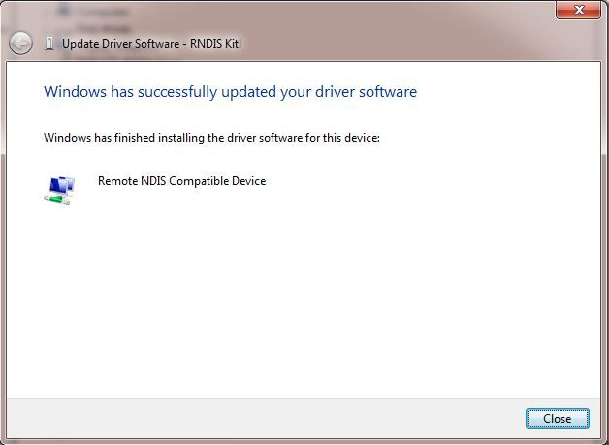

* Upon successful connection, UDOO NEO will be available at the address [192.168.7.2](http://192.168.7.2/), you can access UDOO NEO easily by just typing this address to your browser.

Note: I waste my 1 hour trying to connect UDOO NEO with Micro USB doesn’t support sending data…

**UPDATE: 19/9/2019: Installation of VNC for using UDOO NEO remote**

*As normally, the VNC is already set up and configured in UDOOBuntu OS, but not in our device and some device that install the latest UDOOBuntu OS so in this case we must install manually.*

* sudo apt-get update
* sudo apt-get install tightvncserver¨

To start the VNC server, run:

* vncserver :1 -geometry 800x600 -depth 24

We want the VNC to start with the system, just place the command above to a shell file, and add link to this shell file in .bashrc file.

* Create shell file

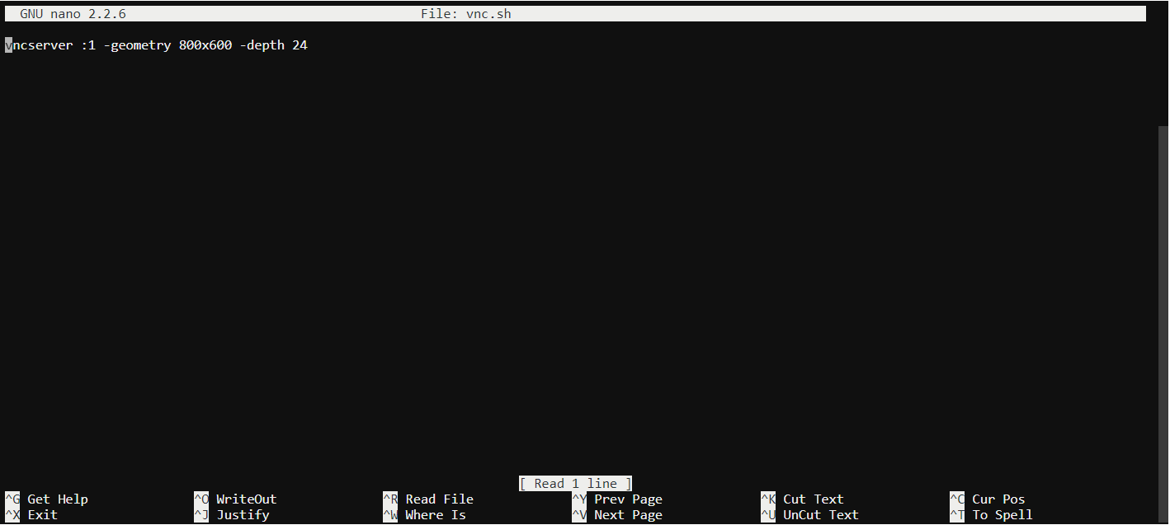

* Add link to shell file in .bashrc

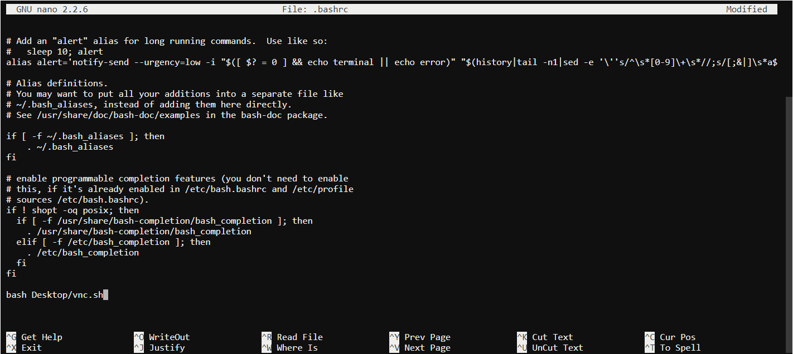

* Then go to your computer and download [VNC Viewer](https://www.realvnc.com/en/connect/download/viewer/).
* Type the IP address of UDOO NEO and Port 5900 (I don’t know how to create a fix IP for our device so we will use the temporary IP address)

